**Milestone 2**

Stephen “Dean” Griggs

Grand Canyon University

CST-250

Bradley Mauger

02/26/2023

In this milestone we were tasked to set up the parameters of a minesweeper game

This included creating a board that set a specific number of rows and columns and then filled those cells randomly with bombs then proceeded to calculate how many mines the non-bomb cells were touching and display that.

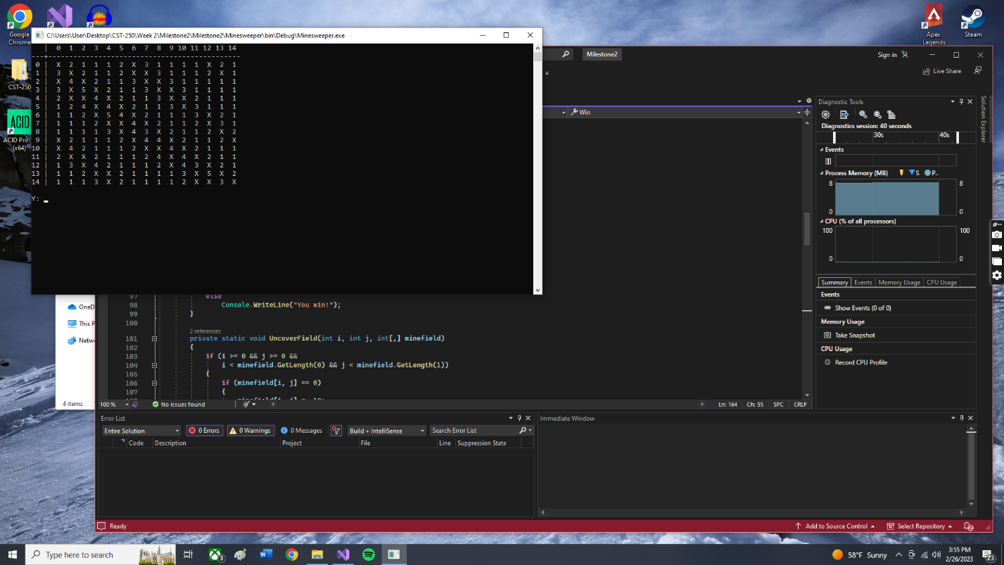

Link:

https://github.com/DeanGriggs/CST250Milestone2